- Know the location, charge and relative size of each of the following:
- Proton  Nucleus  Positive  Same as neutron | - Electron  Electron Cloud (around nucleus)  Negative  2000x smaller than a proton | - Neutron  Nucleus  Neutral  Same as proton

- What is the center of the atom called? Nucleus

- How many electrons can fit in the:
- 1st energy level: __2__ | - 2nd energy level:__8__ | - 3rd energy level: __8__
- What is the Atomic Number? # of Protons

- What is the Mass Number? (# of Protons) + (# of Neutrons) or (rounded atomic mass)

- What are protons and neutrons made of? Quarks

- What force holds the nucleus together? Strong Nuclear Force

- What force holds the electrons around the nucleus? Electromagnetic Force

- What force is responsible for radioactive decay? Weak Nuclear Force

- In a neutral atom, what two particles MUST be the same? Protons and Electrons

- What is an isotope? Atoms with same # protons (atomic number) & different # of neutrons

- What is an ion? Atom that has lost or gained electrons

- What is an anion? Atom that has gained electrons (negative charge)

- What is a cation? Atom that has lost electrons (positive charge)
15. Be able to read an element’s information from the periodic table (you are not responsible for
knowing the chemical names...yet!):
17
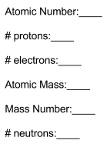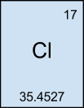
35
35.4527
18
17
17
16. Draw the atom above.
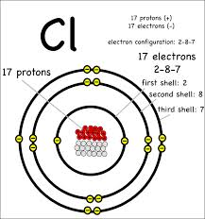
17. For each of the following find the number of protons, neutrons and electrons.
H²⁻ Na¹⁺
Hydrogen that has gained 2 electrons Sodium that has lost 1 electron
1 proton 11 protons
3 electrons 10 electrons
0 neutrons 12 neutrons
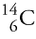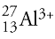

Carbon isotope (Atomic mass of 14) Aluminum isotope that has lost 3 electrons
6 protons 13 protons
6 electrons 10 electrons
14 - 6 = 8 neutrons 27 - 13 = 14 neutrons

